Blackburn Harriers & AC
  - Founded 1883
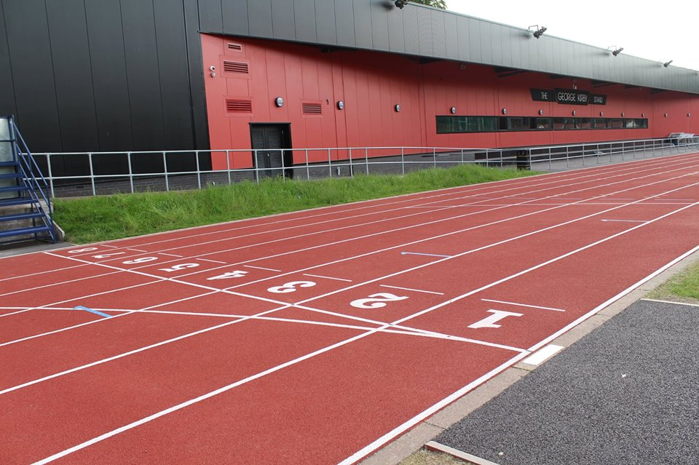
INTRODUCTORY LEAFLET FOR NEW MEMBERS
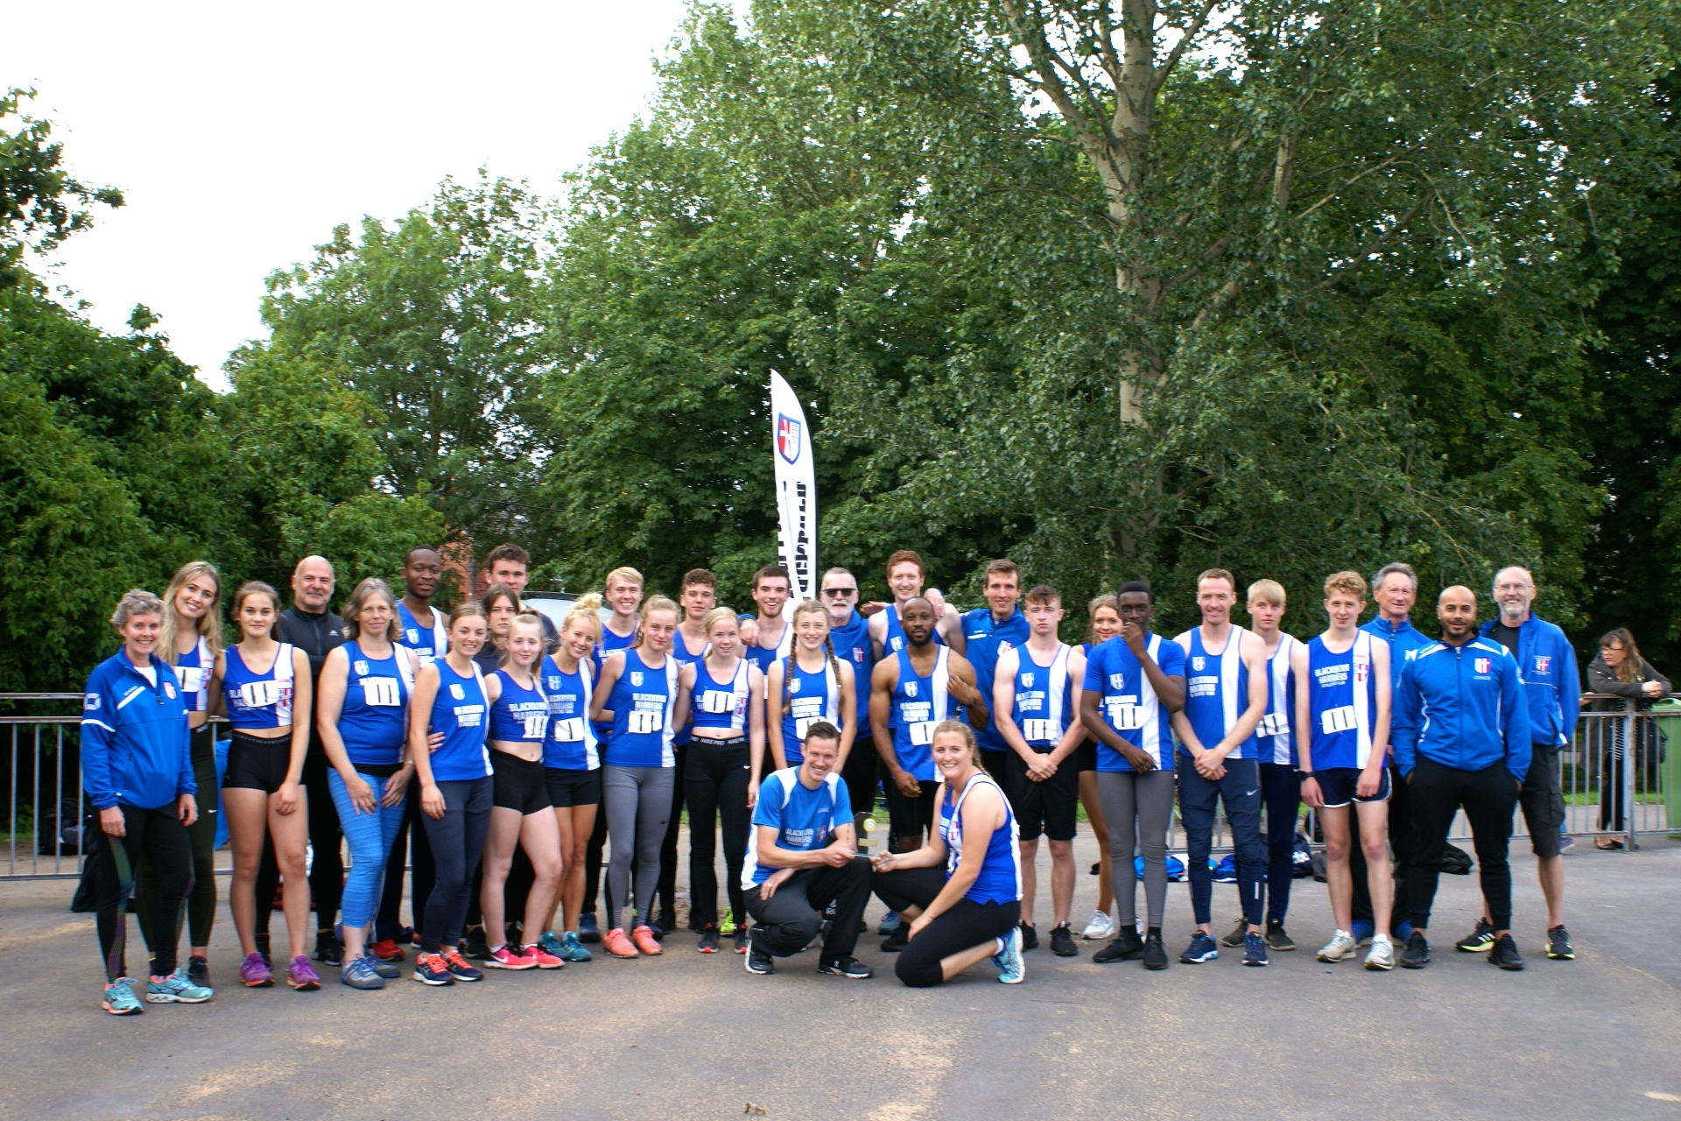

WELCOME TO BLACKBURN HARRIERS & ATHLETIC CLUB
This introductory booklet will help you understand what the Club can offer you, how we organize ourselves and some of the Club’s expectations of you.
Our Rules and Codes of Conduct are there to help you enjoy your athletics.
Safeguarding & Wellbeing
All of our Coaches have DBS clearances and have signed up to the UK Athletics Code of Coaching.
The Club has a Welfare Officer – Paul Guinan pcguinan@btinternet.com 07725-667871
Blackburn Harriers Child Protection Policy Changing Room Policy Junior Rules Club Photography Policy
Code of Conduct for Club Officials, Coaches & Volunteers
Code of Conduct for Parents
Equity Policy
Club Contacts
A list of all Club Contacts can be found on Blackburn Harriers Website at:
http://www.blackburnharriers.co.uk/
Coaches
A list of all the Club Coaches can also be found on the Blackburn Harriers Website alongside their particular disciplines. All have UKA Coaching Licenses and are subject to a Code of Conduct approved by Blackburn Harriers at: http://www.blackburnharriers.co.uk/training/
First Aid
A First Aid kit is kept in the Club Room and all Staff at Witton Park are trained in First Aid as are a number of Coaches. There is a Defibrillator on site with Witton Park Staff trained in its use.
Personal Security
We ask Parents and Carers not to encourage youngsters to leave Witton Park or any external training or competition venue unless accompanied by an adult. This is particularly important during wintertime. The first point of contact with the Club at Training Sessions is Witton Park Club Room – until then, your child is your responsibility. We encourage all parents and carers to stay whilst their child is training.
Training Equipment / Valuables
Please ensure that your child’s sports kit is appropriate for the weather and valuables are kept to a minimum. Tracksuits, tops, jackets etc. should have a named label inside them in case they are left behind after training and lost. The Club is not liable for loss, theft or damage as this is the responsibility of the individual athlete.
Blackburn Harriers has a separate Clothing Page on its website where you can order on-line, various items of training and competition clothing.
Training
Blackburn Harriers has exclusive use of Witton Park Arena Outdoor and Indoor Tracks on Tuesday, Wednesday and Thursday evenings from 5.30 through to 8.30. We also have exclusive use on Sundays from 11.00 – 1.00pm.
Please note that in order to use the facilities you must have a Beez Card issued by the Borough (BwDBC) which is purchased at Reception at Witton Park and is payable by Direct Debit. Parents must set up the Direct Debit for all children under 18yrs of age.
Track Safety
All members MUST pay special attention to safety awareness when down at Witton Park in training sessions.
With large numbers of athletes using the track on club nights the importance of operating safely cannot be stressed too highly. With senior athletes moving at speed on the same track as many smaller athletes there is plenty of scope for injury if proper care is not taken. The committee in conjunction with coaches has drawn up some simple common-sense rules which everyone using the track is expected to observe.

- In common with most tracks, Lanes 1 and 2 are not for general use, to avoid excessive wear. Warmups and cool downs should be in the outside lanes or outside the track area.
- Sprinters and Hurdlers will be using Lanes on the home straight on their training nights. Care will be needed with jog or walk recoveries in this area, particularly to avoid any interference with athletes running at speed and with use of the jumps runways.
- Jog or walk back recoveries must be in narrow file rather than spread across several lanes.
- Overtaking of slower runners must be on the outside and not by cutting inside which can lead to serious injuries.
- Take care when crossing lanes, particularly when walking on to the track from the outside and when finishing reps.
- Athletes moving at speed have priority over those doing their recovery, crossing lanes or talking.
- The Under 11 group may be using the track in the summer (April to September). Please be aware of their presence and be appreciative of their age and understanding.
- Do not cross the inside area of the track by running or walking across the field. This can be very dangerous as it may be being used for throwing events and training.
- Please ensure when involved in training on the track on official Club sessions you are under the supervision of a Club coach otherwise such training is not allowed by the club and you are not covered under the UKA insurance scheme.
- Everyone using the track during a club session must have registered their presence and paid (unless exempt) at the clubroom.
- Please remember that everyone who uses the track has an equal right to do so and respect that right.
- Abuse and foul language have no place at Blackburn Harriers. Let us ensure this remains a friendly club. Breach of this rule may result in disciplinary action.

Our Sportshall Group which caters for 8 – 11yrs meets on Wednesday evenings with two sessions (1) 6 – 7.00pm & (2) 7 – 8.00pm. In the Summer this group trains at Witton Park and during the Winter months they go inside and train at St Wilfred’s School.
Please also be aware that Car Park Charges exist for the main Car Park and the area is patrolled by traffic wardens.
Competition
The Club is involved in Track & Field, Cross Country, Road and Fell Racing:
- UKYDL (Lower Age Group) for U13 & U15 athletes
- UKYDL (Upper Age Group) for U17 & U20 athletes
http://www.ukydl.org.uk/
- Northern League for U17, U20 and Senior athletes
https://www.northernathletics.co.uk/track-field-league/
- Mid Lancs League for all age Groups – U13 and upwards
http://www.midlancs.org.uk/
- County, Regional and National Track & Field Championships
Blackburn Harriers is also affiliated to Northern Athletics https://www.northernathletics.co.uk/ and Lancashire Athletics Association http://www.lancsaa.co.uk/index.html

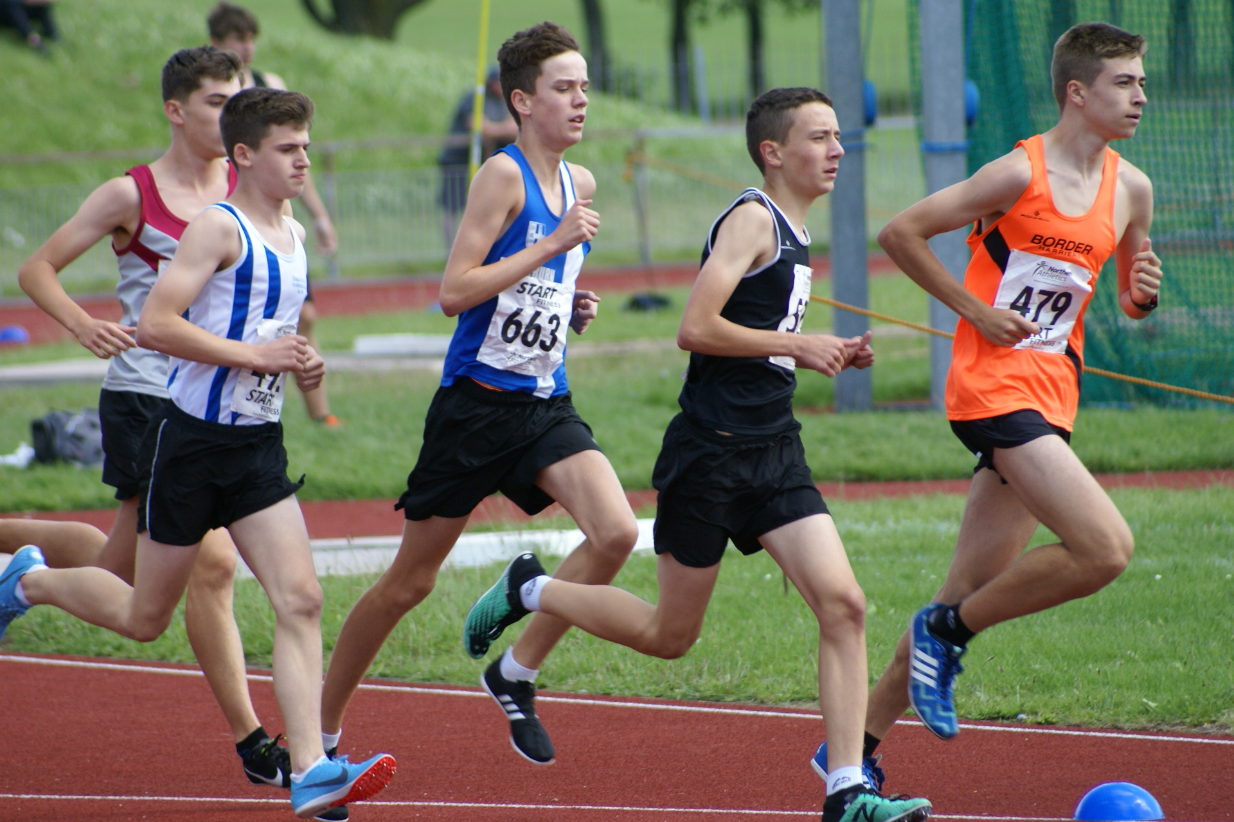

- Red Rose Cross Country League for all age groups from U11 upwards
https://redrosecrosscountry.co.uk/

- Mid Lancs Cross Country League for all age groups from U11 upwards
http://www.midlancs.org.uk/

- Town, County, Regional and National Cross Country Championships
http://www.lancsaa.co.uk/index.html
https://www.northernathletics.co.uk/

- Cross Country Relays at Regional and National level

All competition and events information can be found on the Blackburn Harriers Website:
http://www.blackburnharriers.co.uk/

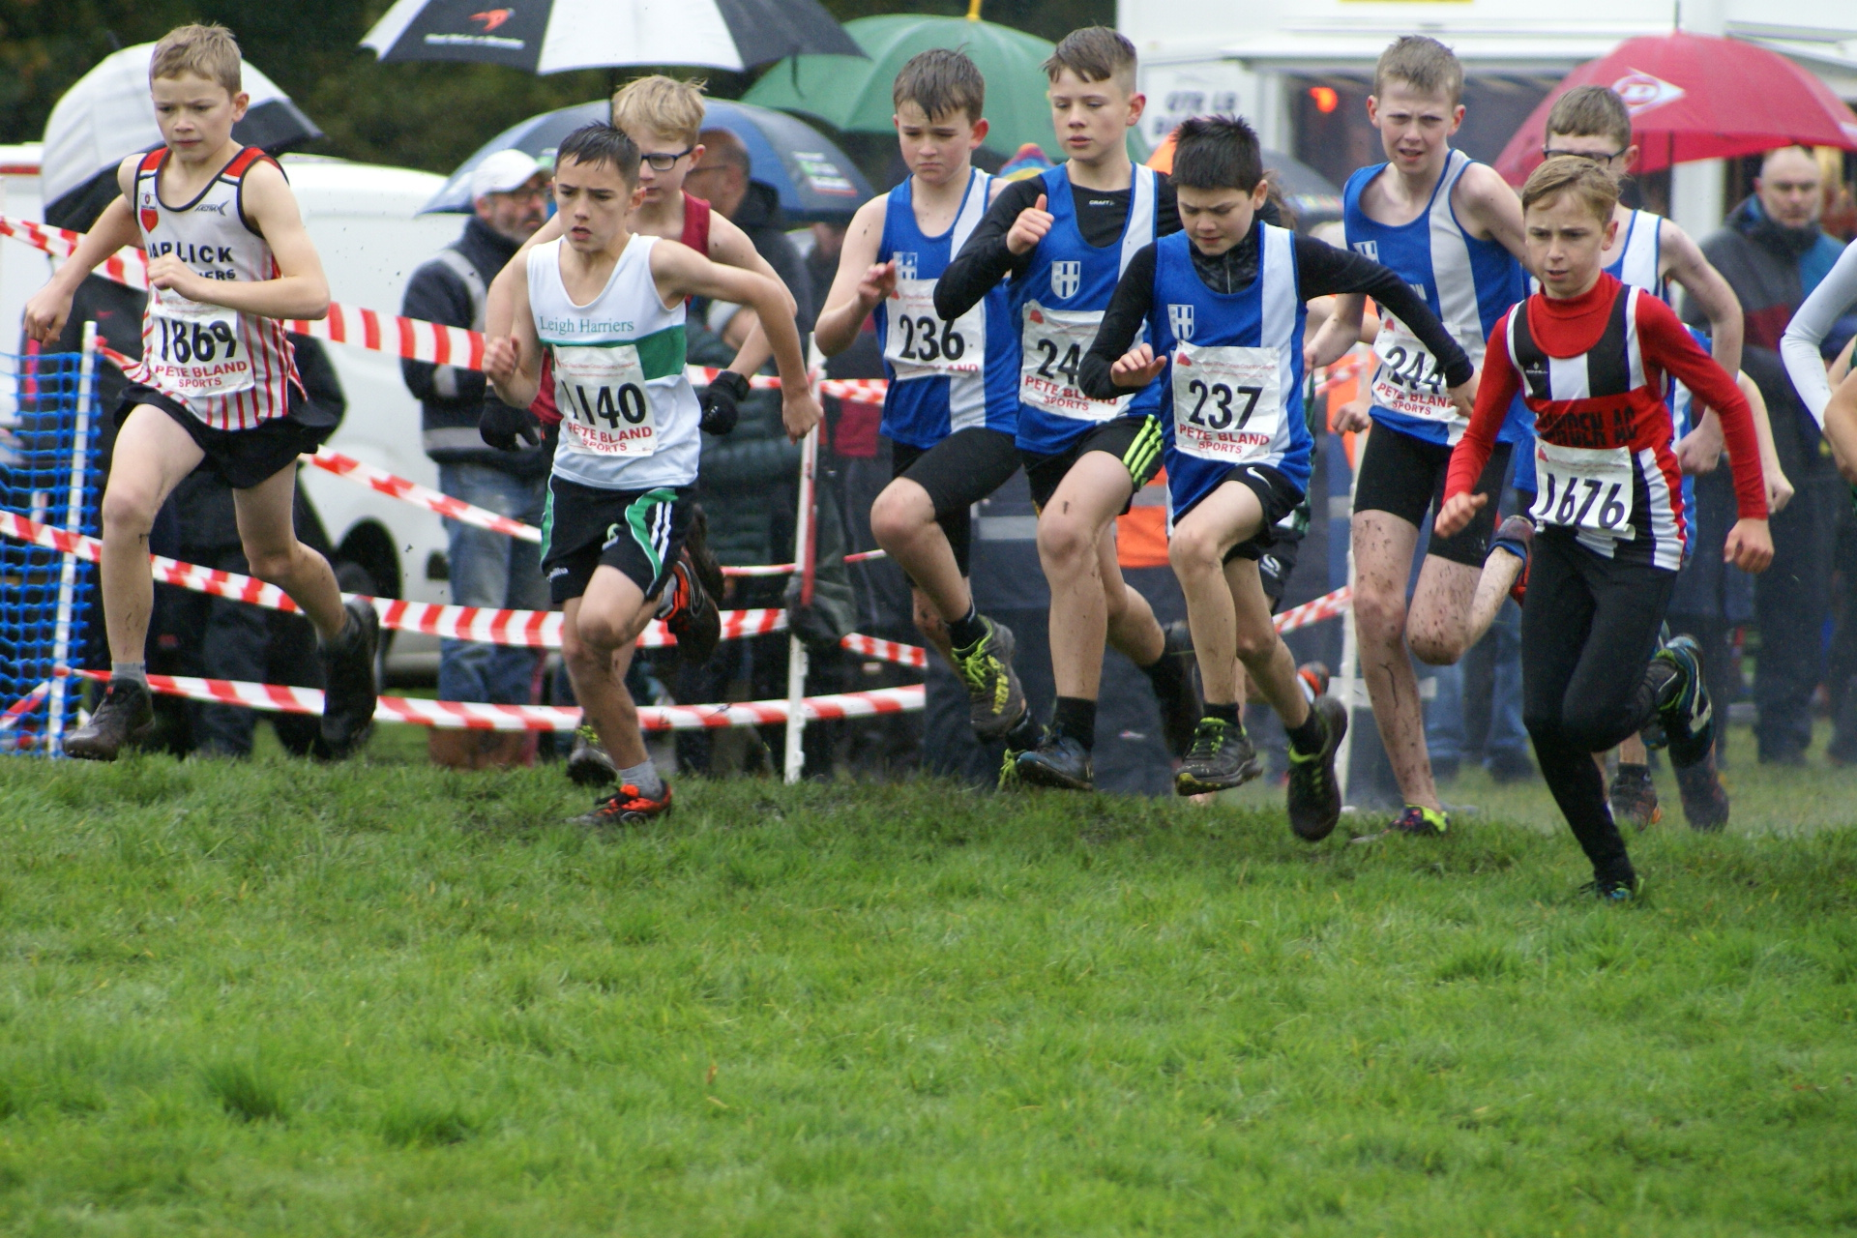

- Road Relays at County, Regional and National level
http://www.lancsaa.co.uk/index.html

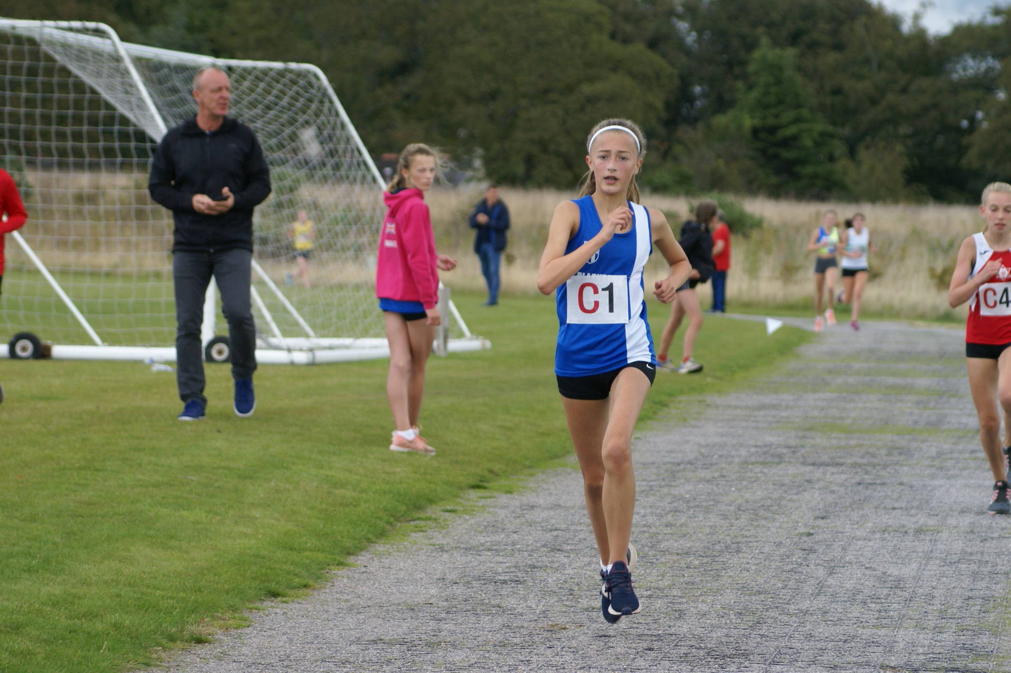

- Fell Races and Championships
https://www.fellrunner.org.uk/

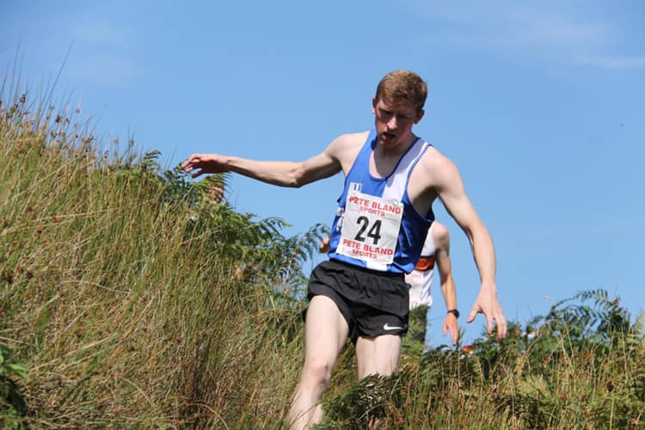

Annual Membership Fees
- Family membership £90 plus the £19 EA levy for each competing athlete
- Senior membership (21+) £60 which includes the EA levy
- U13-U20 membership £55 which includes the EA levy
- Under 11 membership £35 No EA levy to be paid
- Social member £28
- 2nd claim members £10 ----- EA levy to be paid to 1st claim club

Your Membership Dues can be paid either by:

Payment directly on-line via the Harriers Website: https://www.blackburnharriers.co.uk/product/club-membership/
Payment into the Harriers Bank Account: Sort Code 089299 --- Account Number 65654886
By Post to Membership Secretary 185 Shorrock Lane, Blackburn BB2 4TT

(NB) Your Annual membership fee includes your registration fee paid by the Club to England Athletics and results in you being covered by insurance whilst involved in club athletics and gives you eligibility for competition with your own unique Competitive Licence.

Getting Involved
Blackburn Harriers and all that it is engaged in, all that it organizes, is done by unpaid volunteers. Some are parents, some are athletes, some former athletes, some who just want to put something back into the Club.
We always need people to step forward and assist the Club, either by volunteering to become an Official for Track & Field Fixtures, Cross Country Fixtures; or, getting involved in helping Coaches with a view to becoming a qualified Coach.
We also need people to consider getting involved in the Club Committee and taking up responsibilities associated with the day to day organization that is required in providing training and competition for all its members.
If you are wanting to get involved, please e-mail georgedavies48@sky.com

